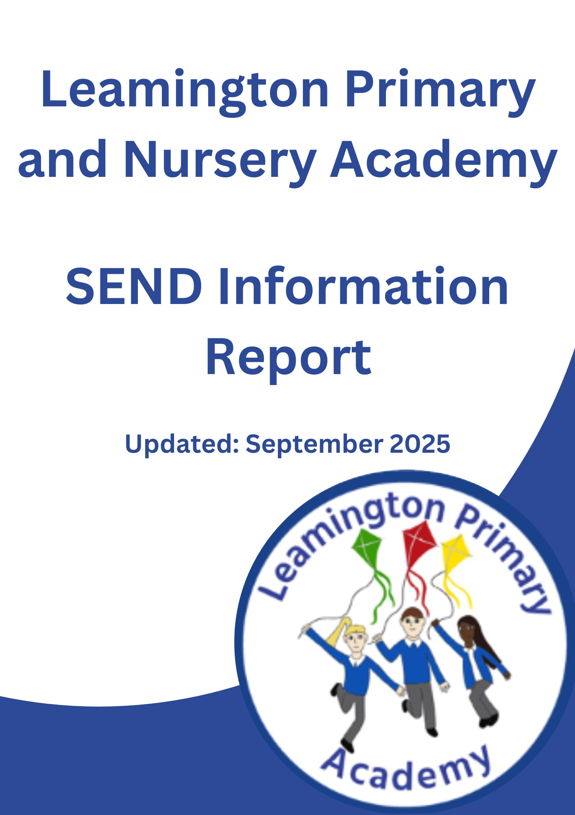

Our Curriculum Vision Statement
At Leamington Primary Academy, our curriculum, underpinned by current research, has been specifically developed and adapted for the needs and interests of all our children. Our curriculum is carefully designed to address identified barriers of learning from within our community. Fluency in the core subjects, with reading at the heart, enables access to the full curriculum and is therefore integral to our approach.
We know that our children need a curriculum that embeds knowledge, expands vocabulary and captures their imagination. Our curriculum allows children to retain knowledge and vocabulary. It is carefully designed so that children can build on knowledge and skills learned and use them in the next stage of their education. An ambitious curriculum based on compassion, integrity and a pursuit of excellence, opening doors for the future success of all of our children to fulfil their potential and beyond.
Our enquiry-based approach takes children on a journey of memorable learning through rich and purposeful experiences, culminating in authentic outcomes which leave a legacy.
Our curriculum is adapted and made accessible for all children at Leamington Primary and Nursery Academy regardless of any SEN and Disabilities.
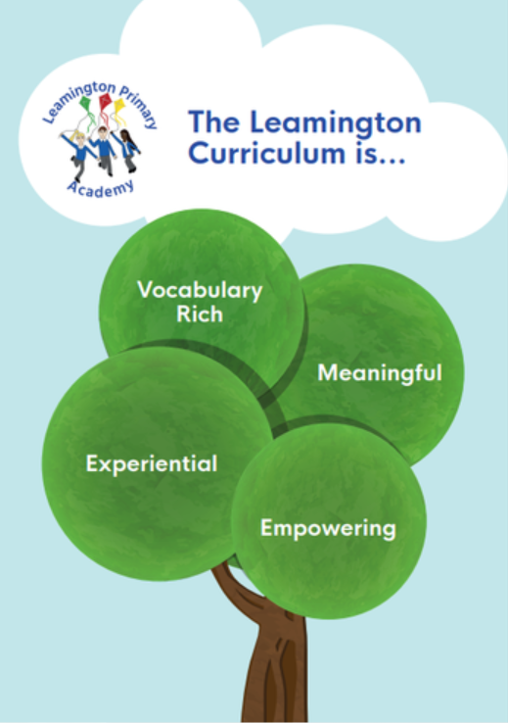

Vocabulary Rich to access high quality texts and improve speech and language.
Empowering to raise aspirations of the children within the community.
Experiential to ensure all children can access learning.
Meaningful to give learning a purpose that prepares them to be compassionate citizens of our world.


Meet the Leamington Primary and Nursery Academy Inclusion Team:
Miss Culley is the Inclusion Leader and SENDCo in school.
She has responsibility for coordinating the provision for all children in the school who have Special Educational Needs or disabilities. Miss Culley is also Attendance and Behaviour Lead and Designated Teacher for looked after and previously looked after children. You can contact her at culleyt@leamingtonpa.org.uk, via dojo or by phoning the school office on 01623 455951.

Miss Culley is supported by a highly trained and experienced inclusion team in the day-to-day support for children with SEND.


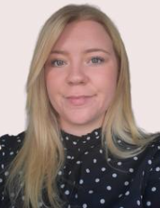



Miss Pitchford
Family Support Worker
Designated Safeguarding Lead
Miss Smythe
Family Support Worker
Designated Safeguarding Lead
Mrs Buckley
Assistant SENDCo
Class Teacher
Mrs Rodgers
Pastoral Support
ELSA (Emotional Literacy Support Assistant)

How do we identify children with SEND?
Some children will enter school with very clearly identified needs, however for others their needs do not become fully apparent until they enter or progress through the education system. Class teachers will make regular assessments of progress for all pupils and during this process will identify those whose progress or attainment is becoming a cause for concern. This is done through:
- Regular communication with parents/carers
- Regular communication as a staff body
- Transition meetings when a child is new to school
- Pupil progress meetings
- Data analysis
- Learning walks
- Book looks
- Pupil, staff, and parent questionnaires.

The Graduated Approach:
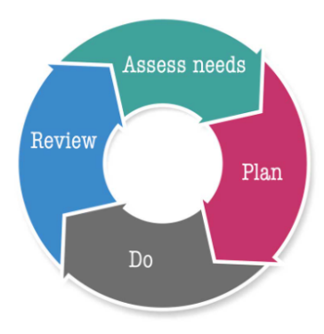
We follow the graduated approach by implementing the ‘assess plan, do, review’ approach. This involves adapting high quality first teaching strategies, planning interventions and strategies and reviewing their impact and gathering further information to create a clearer picture of the child’s needs. Depending on the identified need, this could involve observations by the SENDCo, outside agencies, completion of checklists or formal assessments.

How do we work with parents and carers?
When a child’s progress in any aspect of their development becomes a cause for concern, we will have an early discussion with the pupil and their parents when identifying whether they need special educational provision. These conversations will make sure that: • Everyone develops a good understanding of the pupil’s areas of strength and difficulty. • Everyone understands the agreed outcomes for the child and what the next steps are. We will notify parents when it is decided that a pupil will receive SEND support and parents will be invited into school to create a SEND Support Plan about their child. This will outline the support the child is receiving and will include:
• The child’s current assessments
• Their identified barriers and strategies to address these
• The pupil’s own views
• The parent’s views
• A clear outline of the provision for the pupil with clear targets and measurable outcomes.
Parents then continue to be included at every step of their child’s journey through regular (at least termly) reviews of the support in place.
What is our approach to teaching children with SEND?
Adaptations to the curriculum and learning environment
Teachers are responsible and accountable for the progress and development of all the pupils in their class and therefore high-quality teaching and learning for all pupils is our first step in responding to pupils who have SEND. This will be adapted for individual pupils to enable them to access the curriculum alongside their peers.

We make the following adaptations to ensure all pupils’ needs are met by:
• Scaffolding our daily provision to ensure that all pupils are supported to access the curriculum alongside their peers for example by giving longer processing times, pre-teaching of key vocabulary, reading instructions aloud, etc.
• Adapting our resources and staffing
- Bespoke provision may be planned for and provided to ensure that the needs of all our children are met in line with the principles outlined in our SEND policy.
All staff have a copy of and refer to a document entitled ‘High quality teaching for SEND’ which contains strategies to support children in the classroom under the 4 categories of need. There are also documents to support more specific adaptations in each of the individual subject areas available.
Additional interventions and support
Where it is identified that a child needs something additional to the adaptations made in the classroom, we also provide additional interventions such as:
• Additional Little Wandle sessions for phonics
- SHINE reading interventions
• Precision Teaching
- B-Squared Interventions
- Attention Autism
• ELSA (Emotional Literacy Support Assistant)
- Drawing and Talking
- Tree of Life
- Individual Speech and Language Therapy programmes (SaLT)
- Sensory circuits
- Forest Schools
- Additional support is provided at break and lunch times, for those pupils who find the unstructured parts of the day difficult.

Outside agencies
The school continues to build strong working relationships and links with external support services to fully support our children. We believe that sharing knowledge and information with our support services is key to the effective and successful SEND provision within our school. With consent from parents, we also work with agencies to provide additional support for pupils with SEND, such as:
• Schools and family specialist services (SFSS)
• Educational psychologists
• NAP (North Ashfield Partnership)
• SaLT (speech and language therapy)
• CAMHS (Child and adolescent mental health services)
• Occupational therapy
How do we support children’s wider development and well-being?
We recognise that children’s development and progress is not only measured by academic success and therefore provide support for pupils to improve their emotional and social development in the following ways:
- We have a school council in which all children are supported to have a voice.
- We have an ELSA (Emotional literacy support assistant) who can provide support for those children who need more targeted emotional support.
- We have a sensory room which all children can access.
- We have two Family Support Workers who will work with the whole family to support positive outcomes for the child.
- Children with SEND can access all extra-curricular activities and participation is actively encouraged.
- Attendance monitoring and support through our Inclusion Leader and family support workers.

We also ensure that all members of our school community are treated with tolerance and respect. This is taught as part of our PSHE curriculum and through regular whole-school assemblies.

How do we know that the support in place is working?
We evaluate the effectiveness of provision for pupils with SEND through:
• Reviewing pupils’ progress towards the outcomes on their SEND Support Plans.
• Holding termly SEND reviews with parents, teachers and the child.
• Reviewing the impact of interventions on a regular basis.
• Listening to and capturing the pupils own voice and involving them in their reviews where appropriate.
• Regular monitoring by the Inclusion Leader by visiting children in classes, looking at their work and attending pupil progress meetings.
• Consulting with and taking feedback from outside agencies.
• Holding annual reviews for pupils with EHC plans.
• For those children who it is not possible to track progress against the usual methods, we use appropriate small step tracking systems appropriate for the area of need, such as B-Squared, Autism Education Trust Framework, Motional Assessments and SDQs.
What support will there be for my child’s overall well-being?

All staff work closely together in helping to support our children and reinforce our school principles at all times. We provide additional support for children when they are experiencing difficulties with their emotional health and wellbeing. This is organised by the Inclusion team in conjunction with the class teacher and parents.
Additional support is provided at break and lunch times, for those pupils who find the unstructured parts of the day difficult. We also cater for the medical needs of certain children in the mainstream setting as well as a lunchtime club to support those who require a more structured session.

Mid-day staff receive regular training for specific children in their care, to meet their medical and/or social needs.

What training have staff had and what is planned?
Our school is committed to ensuring that all staff are provided with opportunities to enable them to support children with a range of specific needs. As a child joins the school or new class, specific training is put in place to ensure that the child’s needs can be met.
The Inclusion team attend relevant SEND courses, Family SEN meetings and facilitates/signposts relevant SEN focused external training opportunities for all staff.
We aim to keep all school staff up to date with relevant training and developments in teaching practice in relation to the needs of pupils with SEND. Whole staff training is carried out on a regular basis to increase staff’s knowledge and understanding of a wide range of topics related to special educational needs and disabilities.
The school is a member of the Sutton Centre Family of schools, the Flying High trust and the Flying High teaching alliance. This enables the schools to build a bank of joint resources and to share advice, training and development activities and expertise.
How will equipment and facilities for SEN be secured and how accessible is the school?
Leamington Primary and Nursery Academy endeavour to comply with accessibility requirements regarding the physical environment and access to the curriculum.
Our current arrangements and identified adjustments are outlined in our accessibility plan (available on the school website) and we recognise that modifications may need to be put in place to meet the needs of all pupils.
The school currently has a range of facilities for pupils with SEND in place. These include:
- Full time teaching assistants (who have expertise in a variety of areas)
- Use of dyslexia friendly resources throughout school
- Disabled toilet facilities
- Hygiene room
- Lift to second floor
- Sensory room
- Translation services
- Use of dual coding with signs and symbols for those pupils with communication difficulties
- Use of iPads and technology
- Visual timetables in all classrooms
- Information from the school office (for parents) available in a range of formats, including large print, translated and copied onto coloured paper (dyslexia friendly) upon request.
If a situation arises where specialist equipment was needed, then advice would be sought from specialist services such as Physical Disability Support Service and Inclusive technology.
How will the school prepare my child to join the school setting?

When a child with additional needs joins the school, every effort is made to ensure that they have a smooth transition and that training resources are in place to meet their individual needs.

The Inclusion team will liaise with the child’s previous school or setting to ensure that all the relevant information has been shared, so the best possible outcomes can be achieved.

How will the school prepare my child to transfer between phases of education?

The Inclusion Leader will co-ordinate and oversee transition into different educational settings and ensure that the provision is appropriate to children’s individual needs. The Inclusion Leader will ensure liaison between staff members within school to ensure that the provision is individualised where needed. As pupils move to a new class, plans are put into place to support both the pupil and new staff to enable them to successfully transition alongside their peers. This may include additional visits, creating photo books, meeting of new staff and facilitating appropriate staff training. See below:

The school closely liaises with local secondary schools to enable an effective transition to take place. Parents are actively involved through this transition process.

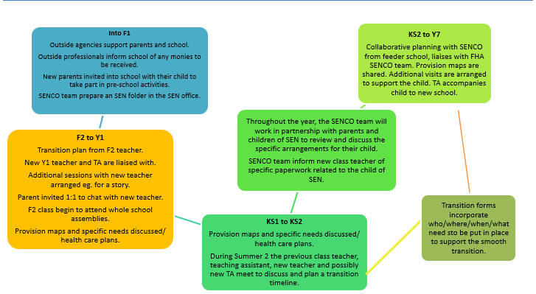

How will the school prepare my child to prepare for adulthood and independent living?
Every part of our curriculum will provide children with the opportunity to develop skills that they need to be successful life-long learners our principles support this. We also encourage independence in our children and ensure that they have the necessary skills to live as independent, successful adults. Our motto “Look back with pride and forward with confidence” underpins our work throughout school. All children have access to a full PSHE program where they will study features of adult life appropriate to their age and development.

What do I do if I have a concern or complaint about the SEN provision made by the school?
If a parent or carer has any concerns or complaints regarding the SEND provision for their child, they are advised to speak to the relevant class teacher or they can make an appointment to speak to the Inclusion Leader, where ways forward and steps to resolve the issue will be discussed.
If parents feel the matter is still unresolved and would like to submit a complaint, then a full copy of the complaints procedure can be obtained from the school office upon request.
How does the school seek to signpost organisations, services etc. who can provide addition support to parents/ carers / young people?
Additional services are recommended to parents, carers and young people as and when a need arises. Services which may be recommended include support groups, charitable organisations, clubs for children and the Parent Partnership Service.
Parents will be signposted to Nottinghamshire local offer page on the website, access to this can be supported by school if parents have difficulties accessing a computer.
www.nottinghamshire.sendlocaloffer.org.uk

The SEND Local Offer is a resource which is designed to support children and young people with special educational needs and/or disabilities and their families. It describes the services and provision that are available both to those families in Nottinghamshire that have an Education, Health and Care Plan and those who do not have a plan, but still experience some form of special educational need.

