

Positive Behaviour
Policy

2026-2027

Positive Behaviour Policy

Our School Rules:

At Leamington, we are:
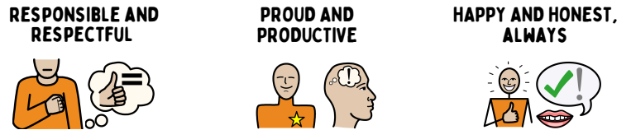

It is a primary aim of our school that every member of the school community feels valued and respected, and that each person is treated fairly and well. We are a caring community whose principles are built on mutual trust and respect for all. Our school’s Positive Behaviour Policy is therefore designed to support the way in which all members of the school can live and work together. It aims to promote an environment where everyone feels happy, safe and secure.

Leamington Primary Academy is driven by our Flying High Partnership principles. These principles underpin everything we do at Leamington. They are displayed around school.

Our School Ethos

Everything we do starts with positive relationships- building, maintaining and repairing them.
We believe that children deserve our time – time to talk, time to explain and to find solutions. At Leamington, we believe in and practice a relationship based and restorative approach to understanding behavior. This approach is underpinned by 3 key principles.
1. Unmet Needs: Behaviour often reflects unmet needs. Therefore, to change behaviour, we must respond to the unmet need e.g. the need to feel safe, hunger, positive self esteem
2. Individual Influences: Children’s behaviour cannot be fully understood in isolation. It needs to be understood within the contexts or environments in which they develop e.g. their family, community, school
3. Relationships: Within trusted relationships, children can learn, accept their individual strengths, accept areas for development and explore strong emotions and experiences.

- We know that empathy is at the core of building positive relationships: the ability to share someone else’s feelings or experiences by imagining what it would be like to be in that person’s situation.
- We also appreciate the gravity of acting ‘In Loco Parentis’ (in place of a parent). We have a duty of care towards our children, promoting safety and welfare. The level of this duty of care is measured as being that of a ‘reasonable parent.’
- We know that, as adults, ‘we make the weather’ and it is up to us to ensure that all children feel safe and happy.
- We ensure that our children enjoy a safe and calm environment in which they are treated with dignity and respect.
- We provide all children with a clear, consistent and fair approach to behaviour.
- We base our support on equity as opposed to equality. We know that each child deserves the support that the need as an individual (equity), and not necessarily the same support as everyone else (equality).

A simple set of co-created school agreements linked to our school rules, ensures clarity for all. Everyone in the school community is expected to respect and follow these agreements. The children are reminded of the agreements frequently and they are displayed in every classroom and in shared areas around school.
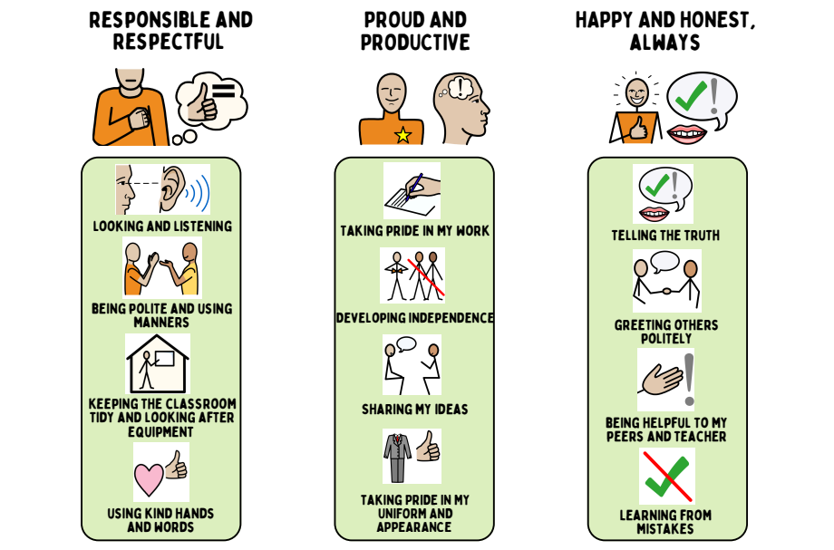

Positive Behaviour Culture

At Leamington, we are relentless in promoting a positive behaviour culture based on safety, consistency, clarity and dignity. There is a high expectation that all children and adults in school adopt and promote this culture at all times.

Our culture is embedded within Leamington’s Positive Behaviour Curriculum. Our behaviour curriculum outlines how we do things at Leamington to ensure success. This is positively reinforced at all times by all members of the school community. It is modelled by everyone and it is actively taught. Leamington’s Positive Behaviour Curriculum is prominently displayed in all classrooms and around school so that it is visible in shared areas, corridors and all outside areas.

The aim is that our behaviour curriculum becomes so embedded that it is habitual and instinctive – a way of being at Leamington.

The Leamington Behaviour Curriculum is outlined in Appendix 3.

Rewards

It is a firm belief at Leamington Primary Academy that children should receive rewards for good behaviour. We aim to instill in our children a strong sense of ‘the right way to behave’ through very high expectations which are consistently reinforced by every member of staff in the school. We praise children for good behaviour in a variety of ways:

- Verbal praise and congratulations
- Stickers
- Whole class rewards
- Class Dojos linked to the school principles for going ‘above and beyond’
- House team rewards termly
- Star of the Week assembly
- Superstar of the term

Whole School Reward Systems


Class Dojos
Class Dojos are a whole school reward system. Any member of staff can award a single Dojo at any time, to any child when they demonstrate one of the three school principles. This is added to the online Class Dojo. Points focus on the school rules and principles. Dojo Points can be awarded by any member of staff both inside and outside the classroom. These are then used as house points and are added to the house totals each week. The winning house receives a reward each half term. Dojo is also used to communicate positive messages to parents about their child’s attitude and for sharing examples of their work. It is expected that each child will be praised and examples of their work will be shared via a Dojo message regularly in order to reinforce positivity.
Star of the Week
Star of the Week certificates are to be awarded to a child from each class. They are to be presented in the Celebration Assembly on a Friday and should be awarded to those children who have shown good attitudes to learning/school life through the week. The certificates are awarded linked to one of the School Principles.

Head Teacher Award
A Head Teacher Award is a certificate given out by the Head Teacher. These are given to pupils whose worked has really impressed the class teacher, shared with the head teacher and has demonstrated the principles to achieve.

Superstars
At the end of each term, one child from each class is selected as superstar. The teacher completes a star with the reasons why the child has been chosen. A copy goes home and the other is displayed in school.

A restorative approach to challenging behaviour
At Leamington, we promote the use of ‘natural consequences’ – with the support of a trusted adult these can help children to change their behaviour.

Some examples are: writing letters of apology; repairing damage to property; completing missed work in a playtime (but never the full playtime). If missed playtimes are happening repeatedly, the teacher needs to consider what the deeper issue is.

It is however, recognised that sometimes a more structured and immediate approach is required in order to support the child. The intention behind this is that the child has time to reflect, away from the situation. The behaviour will always be assessed against the School Agreements and this will be explained clearly to the child.

Dealing with behaviour is a shared responsibility and it is expected that all staff support one another for the benefit of the child. There is a hierarchy of support and responsibility:

Step | Strategy | Approach
1 | A reminder of expectations and rules | To the whole class, reminder of the rule that has been broken, and thank children who are following the rule(s). Return positively to the task.
2 | A verbal warning (x2) | 1:1 Direct restorative conversation(s) with the child inside the classroom – 1st verbal warning takes place where the child is sat. Adults explain why the rule has been broken, explaining positively how the rule should be followed. 2nd verbal warning, ask the child to move to the side of the room. This invitation is given in a positive manner so that the child knows they have the opportunity to talk and return to their working space positively. Further explain the rule(s) which have been broken, how to follow the rule and return to class.
3 | Reflection time in own class | Move from working space to a reflection area. Go through the restorative questions (on lanyard) through conversation with the class teacher. Option to complete regulation activity.  5 minutes reflection and then return to task.
4 | Time out in partner class | As above but in a partner class.  Log on CPOMs assign to Phase Leader.  If a child is asked to leave the classroom, they should be given time to reflect on their behaviour with a member of staff. Wherever possible, this should be the adult directly affected by the behaviour, to support meaningful reflection and repair. Emotion Coaching and restorative questions will be used to guide this process.
5 | Reflection time (10 mins during Break or Lunch)  Child completes the restorative conversation with class teacher.  If an incident takes place in the afternoon and there is not time for this restorative conversation before the end of the day, this will take place the following day at playtime.  Phone call home by the class teacher– inform parents/carers of reflection time and reasons for this as soon as possible. Invitation for parents/carers to meet, but this is not an expectation. If the child is not regulated, the teacher will inform the parent/carer by the end of the school day. If regulated the child will return to class and back to step 1.
6 | Reflection time with Phase Leader | Phone call to parents/carers by the class teacher  Incident recorded on CPOMs.  Restorative conversation led by Phase Leader with the child.  School Behaviour Lead to monitor behaviour over the remainder of the day/ week.
7 | Reflection time with Headteacher or Deputy Headteacher  (remainder of the session) | Phone call to parents by the class teacher – record on the monitoring system. Class teacher to work alongside Headteacher, Behaviour Lead, SENCO, and parents/carers to review/ create an Individual Behaviour Plan. Behaviour Lead and Headteacher to monitor.
8 | Behaviour continues to escalate after above actions. | Follow up meeting with family, SENCO and member of the SLT – record on CPOMs.  Potential Internal Suspension.  Class Teacher: Develop personalised plans in collaboration with parents/carers and the SENDCo. This may include a SEND Support Plan and/or Individual Behaviour Plan which is agreed and reviewed with parents and carers at least half termly.
9 | Relevant External agency support | Class Teacher: Update all personalised plans with strategies recommended from external agencies involved. Review with parents/carers and external agencies as part of a Team Around the Child approach at least half termly.
10 | Fixed term suspension | Between 1 – 5 days issued by the Headteacher in collaboration with the Governing Body and the Flying High Partnership. Parents and carers informed by the Headteacher in line with Local Authority guidance and protocols. Provision reviewed by school with external agencies and parents/carers. All personalised plans reviewed and updated. Reintegration meeting held with parents and carers which is led by the Headteacher and supported by relevant staff. Child then readmitted into school. Inclusion Leader and Headteacher to monitor.
11 | Permanent exclusion | Determined by the Headteacher and Governing Body in agreement with the Flying High Partnership.

If a pupil is dysregulated or causing disruption to learning, Phase 1 support can be called for by class teachers or support staff when a change of adult or regulation break may be needed. Phase 1 support includes a change of adult from a Teaching Assistant, available teacher or a family support worker.
What is a significant behaviour incident?
A significant behaviour incident is any action by a pupil that:
‘Substantially disrupts learning, poses a risk to the safety or wellbeing of pupils or staff, involves discriminatory or abusive language or conduct, results in harm or injury, or requires intervention beyond standard classroom management.’
If a significant incident occurs, the class teacher or support staff will call for Phase 2 support from the Senior Leadership Team. This includes Miss Burnett, Mrs Maloney, Miss Culley and Mrs Staley. The Senior Leadership Team will decide what action is needed depending on the circumstances. Wherever possible, the action should be restorative in nature.
We are aware that all behaviour happens for a reason and when we are dealing with children who are at climax point, it is essential to take into consideration de-escalation strategies and the ‘Assault Cycle’- Appendix 5. At that moment in time, the child will not be at a point to reflect on their behaviour or discuss their choices. It is paramount that any interaction with the child does not escalate the situation – the child needs to be given time and space.

Whilst the child is returning to baseline, following an incident, there will be no discussion of what has happened (saying nothing does not mean you are doing nothing). The member of staff dealing with the incident will nurture their recovery. This may include offering comfort, sensory room time, drinks etc. Once back at baseline, a discussion will take place around what happened and what the impact of their behaviour has been for other children, staff members, school property etc.

Significant behaviour incidents will be logged on CPOMs against our school rules.

Examples of restorative questions can be found on Appendix 6.

Pupils with SEND

Children may be identified and assessed as having special educational needs. There are times when this impacts on the way children are able to communicate their needs. Adaptations need to be made to provision to ensure any children with SEND have appropriate measures in place to ensure needs are being met. Targets and provision agreed in individual SEND support plans and de-escalation plans will be followed alongside the stepped approach to ensure that there are individual adaptations while also ensuring a consistent and clear approach.
Any staff working 1:1 or 2:1 with a child should carry a radio to ensure contact is maintained with the leadership team. If there is a need for additional support, staff should radio for ‘phase 1’ support if there is a need to ‘tag out’ with adults. If a member of SLT is needed, ‘phase 2’ support should be requested.
Staff working alongside children with SEND should be clear on the level of need, the barriers to learning and the adaptations and plans in place in order to deescalate behaviour if they present. This plan is developed alongside the Inclusion leader who will ensure appropriate training and support is in place for relevant staff. It is important that all staff are aware of children who need significant adaptation and the best approaches in deescalating and supporting the child at times of dysregulation.

Support is sought from professionals to ensure the best provision for children with SEND needs in school and methods are adapted to ensure school is a safe and secure place for all children.

Suspension
Suspension is only used in school as a last resort. The school uses the suspension checklist, developed by Flying High Partnership to support in decision making to ensure the needs of the child are at the forefront.

If the decision is made to suspend a pupil, a letter is sent to the parent outlining the reason for the suspension and a date for a reintegration meeting.
If a pupil with SEND is involved, the SENCO is involved in the reintegration plan to ensure provision matches the needs of pupils.

The governing body is consulted if a suspension takes place. This is prescribed by the School Attendance Regulations 2024.

At reintegration, it may be agreed that a pupil returns on a part time timetable. If this is agreed, the absence is recorded as an authorised absence, with a transition to full time plan in place for the pupil.

Minimising the Need to Use Reasonable Force
As a school, we are committed to reducing the need to use restrictive practices. We recognise that restrictive physical interventions are only entered into as a last resort when dealing with potentially dangerous situations, where there is a risk of harm to children or adults. Restrictive physical interventions must only be used in a person’s best interest and comply with Leamington Primary Academy’s duty of care to students, staff, and visitors.

This policy has been prepared using the following guidance:
- Use of Reasonable Force in Schools (effective until 31 March 2026)
- Restrictive Interventions, including the use of reasonable force in schools (effective from 1 April 2026)
- Reducing the need for restraint and restrictive intervention (publishing.service.gov.uk)
- Keeping children safe in education 2025: part one (publishing.service.gov.uk)
- Reasonable force, restraint & restrictive practices in alternative provision and special schools (publishing.service.gov.uk)
- Reducing restrictive practices framework [HTML] | GOV.WALES
- TSS_diagram_REVISED (restraintreductionnetwork.org)
- Education and Inspections Act 2006 - Section 93
- BILD code of Practice for minimizing the use of restrictive physical interventions; 4th Edition (BILD 2014)
- Keeping Children Safe in Education (KCSiE) 2024: Keeping children safe in education - GOV.UK (www.gov.uk)
- Working Together to Safeguard Children: Working together to safeguard children - GOV.UK (www.gov.uk)
- Equality Act 2010 guidance: Equality Act 2010: guidance - GOV.UK (www.gov.uk)
- Education and Inspections Act 2006: Education and Inspections Act 2006 (legislation.gov.uk)
- Nottinghamshire Safeguarding Partnership (NSCP) Policy, Practice and Guidance :Nottinghamshire Safeguarding Children Partnership
- The Restraint Reduction Network: Restraint Reduction Network
- BILD https://www.bild.org.uk/: www.bild.org.uk
- Use of Reasonable Force in Schools: Use of reasonable force in schools - GOV.UK (www.gov.uk)
- Behaviour in schools: advice for headteachers and school staff: Behaviour in schools - GOV.UK (www.gov.uk)
- Behaviour and discipline in schools: guide for governing bodies: Behaviour and discipline in schools: guide for governing bodies - GOV.UK (www.gov.uk)
- SEND code of practice:0 to 25 years: SEND code of practice: 0 to 25 years - GOV.UK (www.gov.uk)

There are circumstances when it is appropriate for staff in schools and colleges to use ‘reasonable force’ to safeguard children. The term ‘reasonable force’ covers the broad range of actions used by staff that involve a degree of physical contact to control or restrain children. This can range from guiding a child to safety by the arm, to more extreme circumstances such as breaking up a fight or where a child needs to be restrained to prevent violence or injury.

‘Reasonable’ in these circumstances means ‘using no more force than is needed’. The use of force may involve either passive physical contact, such as standing between pupils or blocking a pupil’s path, or active physical contact such as leading a pupil by the arm out of the classroom.

The department believes that the adoption of a ‘no contact’ policy at a school or college can leave staff unable to fully support and protect their pupils and students. The department therefore encourages, principals, governing bodies, and proprietors to adopt sensible policies, which allow and support their staff to make appropriate physical contact. The decision on whether or not to use ‘reasonable force’ to control or restrain a child is down to the professional judgement of the staff concerned within the context of 42 the law and should always depend on individual circumstances.

When using ‘reasonable force’ in response to risks presented by incidents involving children with SEND, mental health problems or with medical conditions, schools and colleges should in considering the risks carefully recognise the additional vulnerability of these groups. They should also consider their duties under the Equality Act 2010 (see paragraphs 86-93) in relation to making reasonable adjustments and their Public Sector Equality Duty. By planning positive and proactive behaviour support, for instance through drawing up individual behaviour plans for more vulnerable children, and agreeing them with parents and carers, schools and colleges can reduce the occurrence of challenging behaviour and the need to use ‘reasonable force’.
- Departmental advice for schools is available at Use of Reasonable Force in Schools
- HM Government guidance Reducing the need for restraint and restrictive intervention sets out how to support children and young people with learning disabilities, autistic spectrum conditions and mental health difficulties who are at risk of restrictive intervention in special education settings, however all schools and colleges may find the information helpful. Use of school or college premises for non-school/college activities

Staff Authorised to Use Reasonable Force
Under Section 93 of the Education and Inspection Act (2006) the head teacher of our school is empowered to authorise those members of staff who are enabled to use reasonable force.
Here at Leamington Primary and Nursery Academy, the Head Teacher has empowered the following members of staff to use reasonable force:
- Teachers and any member of staff who has control or charge of children in a given lesson or circumstance have permanent authorisation.
- Other members of staff such as site management and administrative teams also have the power to use reasonable force if a circumstance should arise in which immediate action should be taken.

Deciding Whether to Use Reasonable Force
When using reasonable force in response to risks presented by incidents involving children with SEN or disabilities or with medical conditions, schools and colleges should consider the risks carefully recognising the additional vulnerability of these groups. They should also consider their duties under the Equality Act 2010 in relation to making reasonable adjustments, non-discrimination, and their Public Sector Equality Duty. By planning positive and proactive behaviour support, for instance through drawing up individual behaviour plans for more vulnerable children, and agreeing them with parents and carers, schools and colleges can reduce the occurrence of challenging behaviour and the need to use reasonable force.
Under English law, members of staff are empowered to use reasonable force to prevent a pupil from or stop them continuing:
- committing any offence;
- causing personal injury to, or damage to the property of, any person (including the pupil himself); or,
- prejudicing the maintenance of good order and discipline at the school or among any pupils receiving education at the school, whether during a teaching session or otherwise.

All members of staff will make decisions about when, how and why to use reasonable force. To help staff in making decisions about using reasonable force the following considerations may be useful:
- whether the consequences of not intervening would have seriously endangered the wellbeing of a person;
- whether the consequences of not intervening would have caused serious and significant damage to property;
- whether the chance of achieving the desired outcome in a non-physical way was low; the age, size, gender, developmental maturity of the persons involved.

Staff are also expected to remember that physical intervention is only one option and for behaviours involving extreme levels of risk it may be more appropriate to gain support from other agencies, including the police.

Staff will be kept informed and have a duty to inform others about the plans around specific children who can present risks to themselves and others. This may include information about SEND, personal circumstance and temporary upset.

Using Reasonable Force
When using force members of staff should only use the minimum amount of force required in achieving the required outcome.
Staff should, where possible, avoid any type of intervention that is likely to injure a pupil, unless in the most extreme of circumstance where there was no viable alternative. Also, staff should avoid using force unless or until another member of staff is present to support, observe or call for assistance.

Staff training
Staff at Leamington Primary and Nursery Academy, who have been identified as needing training in this area, will access training through The Education, Safeguarding, Health & Wellbeing Hub or Team Teach who delivers nationally accredited courses.

These courses provide participants with an insight into recent legislation and guidance that could impact on policy and practice, as well as a range of physical and non-physical strategies to help manage the risks posed by children and young people’s behaviour.

Staff who receive this training will be accredited to use the physical element for a defined period as stated on their certificate. Staff will be expected to attend a refresher course to update their skills and renew their certification every 2 years for Level 1 or every year for Level 2.

Recording and Reporting Incidents
The governing body will ensure that a procedure is in place, and is followed by staff, for recording and reporting, significant incidents where a member of staff has used force on a pupil. The record must be made as soon as practicable after the incident.

While ultimately only a court of law could decide what is ‘significant’ in a particular case, in deciding whether or not an incident must be reported, staff should take into account:
an incident where unreasonable use of force is used on a pupil would always be a significant incident;
- any incident where substantial force has been used (e.g. physically pushing a child out of a room) would be significant;
- the use of a restraint technique is significant;
- an incident where a child was very distressed (though clearly not overreacting) would be significant.

In determining whether incidents are significant, schools should consider:
- the child’s behaviour and the level of risk presented at the time;
- the degree of force used and whether it was proportionate in relation to the behaviour;
- the effect on the child or member of staff.

Staff should also bear in mind the age of the child; any special education need or disability or other social factors which might be relevant.
Sometimes an incident might not be considered significant in itself, but forms part of a pattern of repeated behaviour. In this case, although there is no legal requirement to record such incidents, schools are advised to let parents know about them.

Records are important in providing evidence of defensible decision-making in case of a subsequent complaint or investigation. Staff may find it helpful to seek the advice of a senior colleague or a representative of their trade union when compiling a report.
Leamington Primary and Nursery Academy fully recognises the contribution it can make to protect children and support children in school. The aim of the policy is to safeguard and promote our pupils’ welfare, safety, and health by fostering an honest, open, caring, and supportive climate. The pupils’ welfare is of paramount importance.

For further details please refer to the LPA Child Protection policy.

Post-incident support
Following the use of physical intervention staff and children will be supported, the immediate physical needs of all parties will be met and staff will ensure that positive relationships are maintained.
The health, safety, and welfare of all the people who work or learn at our school are of fundamental importance. We aim to provide a safe, secure, and pleasant working environment for everyone. The governing body, along with the Local Authority, and Flying High Trust takes responsibility for protecting the health and safety of all children and members of staff.

Who created the policy?
This policy was based on guidance provided by Nottinghamshire County Council (NCC) Local Authority and has included input from members of staff, representatives from the governing body and our children.

Who is the policy for?
This policy is for all children, staff, parents and carers, governors, visitors and partner agencies working within the school and provides guidelines and procedures as to how our school supports and responds to behaviour and emotional distress.

Supporting Staff
At Leamington, we recognise the importance of providing emotional support to all staff in order to help manage stress. We do this in the following ways:
- School Behaviour Lead and SLT available to support and advise
- Time for reflection
- A culture where the staff have the confidence to share questions, ideas and feelings
- A team approach to finding solutions (you are not on your own)
- Training – regular training in response to contextual needs
- Guidance from the FHP Inclusion Team
- Health Assured Employee Assistance Programme (EAP)

Supporting Children
At Leamington, we offer our children a range of experiences and programmes to support them in understanding and managing their behaviour choices. These include:
- ELSA and Pastoral sessions
- Educational Psychologist support
- North Ashfield Partnership
- Forest Schools
- Leadership roles for children

Who is the policy for?
This policy is for all children, staff, parents and carers, governors, visitors and partner agencies working within the school and provides guidelines and procedures as to how our school supports and responds to behaviour and emotional distress.
Equality Duty
In developing this policy, and in its implementation, we have had due regard to the provisions of the Equality Act 2010 and in particular our need to:

- Eliminate discrimination and other conduct that is prohibited by the Equality Act 2010,
- Advance equality of opportunity between people who share a protected characteristic and people who do not share it,
- Foster good relations across all characteristics - between people who share a protected characteristic and people who do not share it.

The protected characteristics are sex, race, disability, religion or belief, sexual orientation, gender reassignment and pregnancy or maternity.

Safeguarding
As a school we take all our safeguarding responsibilities extremely seriously. We recognise that young people can be vulnerable in a number of ways and that the dangers in the online world are as much a threat as those in the real world. We have ensured that our staff understand what makes some children and adults more vulnerable to certain risk factors; how to recognise the signs of somebody at risk; and what to do if they have a cause for concern. We include in our consideration of risk radicalisation and extremism; female genital mutilation; forced marriage and honour-based violence; and child sexual exploitation. We will ensure that any changes in behaviour or patterns of attendance are identified quickly and that appropriate action is taken swiftly and is proportionate to the level of concern. We will work with the whole school community to ensure all our stakeholders understand our wider safeguarding responsibilities and work in partnership with us to keep our pupils safe.

Zero-tolerance Approach to Sexual Harassment and Sexual Violence
We are committed to a whole school approach to ensure the prevention, early identification and appropriate management of child-on-child abuse within our school and beyond. We recognise that child-on-child abuse can manifest itself in many ways with some including:
- Sexual Harassment – (defined as the unwanted conduct of a sexual nature, including sexual remarks, sexual taunts, physical behaviour or online sexual harassment)
- Sexual Violence
Pupils are encouraged to report anything that makes them uncomfortable, no matter how ‘small’ they feel it might be.
The school’s response will be:
- Proportionate
- Considered
- Supportive
- Decided on a case-by-case basis

In cases where child-on-child abuse is identified, we will follow our child protection procedures, taking a contextualised approach to support all children and young people who have been affected by the situation. Some of these behaviours and actions have been referred to above and are included in our ‘Child Protection’ and ‘Child-on-Child Abuse’ policies.

Complaints and Allegations
Our school aims to be fair, open and honest when dealing with any complaint. We give careful consideration to all complaints and deal with them as swiftly as possible. We aim to resolve any complaint through dialogue and mutual understanding and, in all cases, we put the interests of the child above all other issues. We provide sufficient opportunity for any complaint to be fully discussed and then resolved. For further details please refer to Leamington’s Complaints Policy.

We will also make clear to pupils that they have a right, and are able to question/complain, about the use of reasonable force.
We will ensure that mechanisms are in place for pupils, parents, carers and staff to voice the opinions, comments or concerns through face to face dialogues, use of home/school diaries or by telephone.

Policy links
This policy links to the following policies in school:
- Relationships and Health Education
- Anti-bullying
- Equality
- Health and Safety
- Child Protection and Safeguarding (linked to KCSIE 2022)
- Physical Intervention
- On-line safety
- Social Media
- Child on Child Abuse
- SEND
- Staff Handbook

Keeping the policy alive
We firmly believe that this policy is a ‘way of being’. It is at the core of our school ethos. Therefore, it is important that it is evident in our daily practice.

Strategies to keep the policy alive:
- In staff meetings/phase meetings the Behaviour Lead will regularly share something related to the policy (top tip, verbal reminder of a key point, examples of excellent practice …).
- Each ½ term there will be a staff meeting section in which the Behaviour Lead will present a scenario for discussion/give the opportunity for staff to problem-solve an issue/share a strategy/deliver an element of CPD from research.
- A detailed behaviour analysis is completed each half term by the Behaviour Lead to unpick incidents further and identify next steps.
- The School Rules and Principles are displayed in classrooms and around school.
- A hall display will be created to act as a visual reminder to children and to be used as a learning resource.
- The policy will be reviewed by all staff annually.

Policy written by: Behaviour Lead in consultation with all staff
Date revised: February 2026
Approved by: Kaye Burnett (Head Teacher)
Review date: February 2027
Next review: December 2017
Signed:
Chair of Governors, Di Morphew
Head Teacher, Kaye Burnett
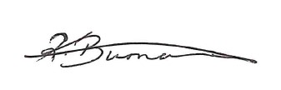

Appendix 1

Responding in the moment

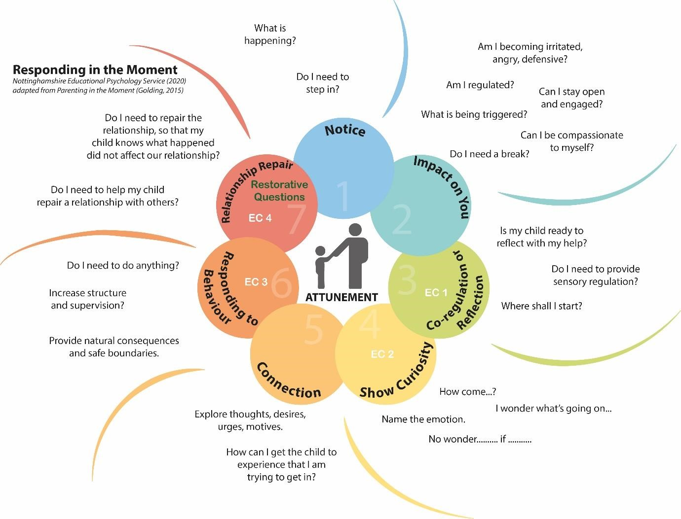

Appendix 2

15 Things to Build Relationships
Tips for Staff

1 | Be who you needed when you were at school. Every child needs a champion.
2 | Make regular deposits into the positive bank.
3 | Know your children well and allow them to know you well.
4 | Difficult child or child with difficulties?
5 | Separate the deed from the doer.
6 | The best apology is changed behaviour.
7 | Catch them getting it right more than you catch them getting it wrong.
8 | Magnify strengths rather than weaknesses.
9 | Strike when the iron is cold.
10 | We learn to care by being cared for.
11 | Smile at children, it’s good for you both.
12 | There is always a solution – you need to give your time to find it.
13 | Never assume you deserve respect – you must earn it.
14 | Calm begets calm.
15 | Sometimes the child knows best!

Appendix 3

The Leamington Behaviour Curriculum
(how we do it here)

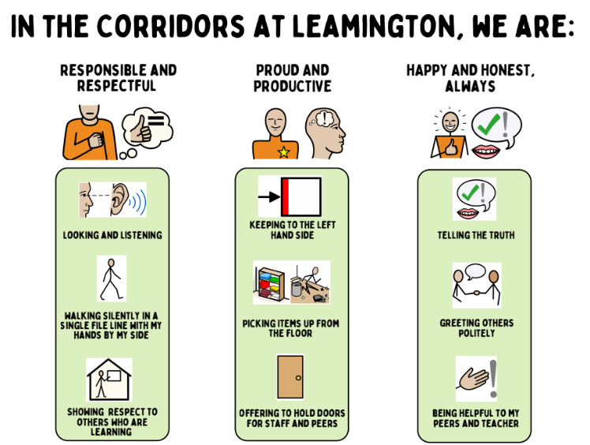
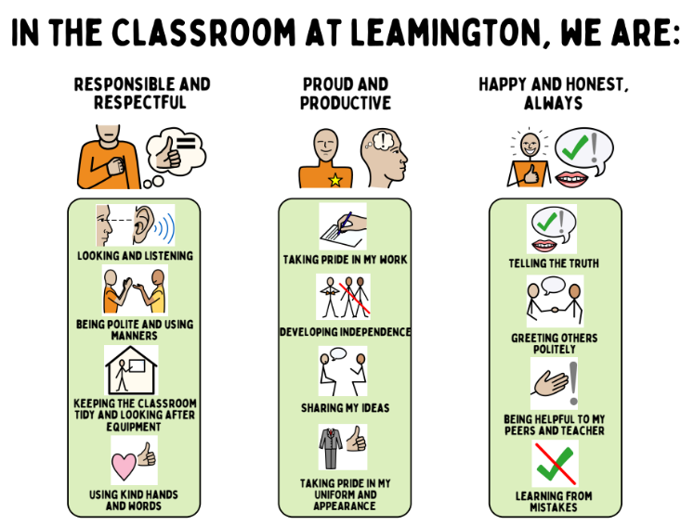

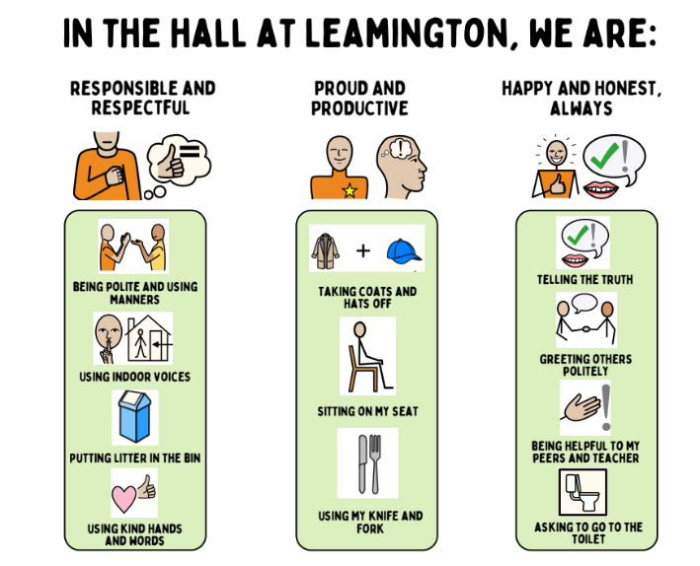
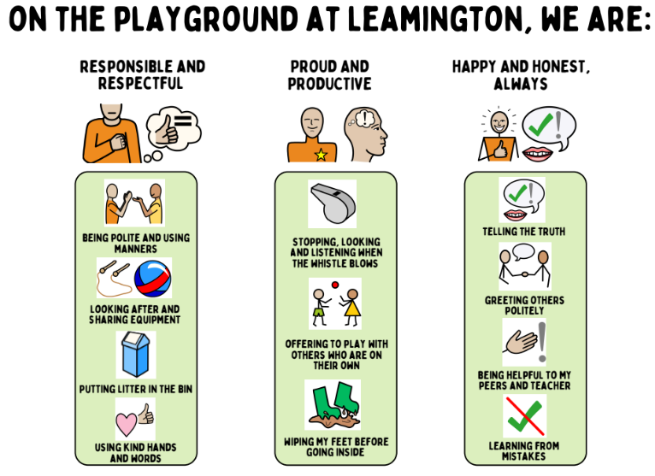

Appendix 4

Behaviour Plan

A behaviour plan is designed to support children in making the right choices and educating them with coping strategies and a ‘toolkit’ for positive behaviours.

The plan will be devised:
- Using a reflection and analysis of the behaviour presented and identification of triggers.
- Creating a flow chart for a personalised plan, in line with the school’s policy.
- A meeting between the class teacher and Behaviour Lead to agree actions and targets to be set, with a clear timeline e.g. referral to outside agencies, pastoral support plan, SALT.
- Planning provision.
- Ensuring Concerning Behaviours Pathway is included as part of the process.
- Parental meeting to be held to discuss behaviour concerns, triggers and to work through the plan with parents and child.
- Risk Assessment if required.

Staff will help children to understand the impact of their behaviour for others following a behaviour incident. This will not be done until the child has been given time to calm and recover following an incident.

If a behaviour plan is drawn up, SLT and Family Support Worker will be informed immediately and a plan forwarded to them.

Appendix 5
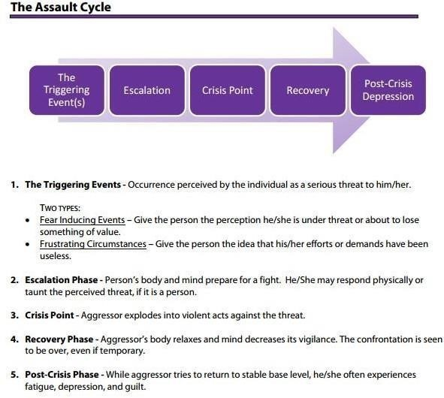

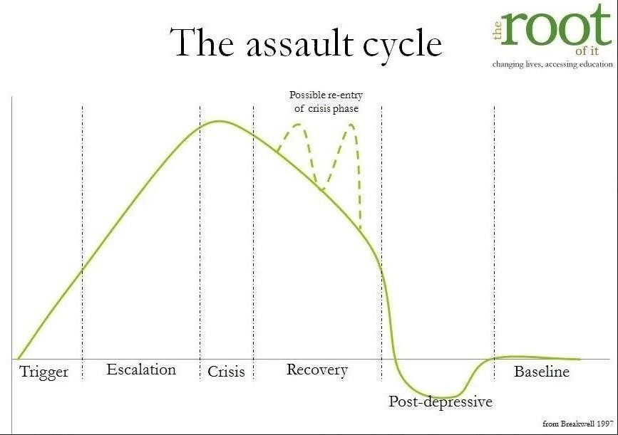

Appendix 6
Examples of restorative questions that could be asked when challenging behaviour:
- What happened?
- What were you thinking of at the time?
- What have you thought about since?
- Who has been affected by what you have done?
- In what way have they been affected?
- What do you think you need to do to make things right?
To help those affected:
- What did you think when you realised what had happened?
- What impact has this incident had on you and others?
- What has been the hardest thing for you?
- What do you think needs to happen to make things right?

Lunchtimes
The school motto applies at lunchtime just as they do at other times.

School Motto

Be responsible and respectful; Be proud and productive; Be happy and honest, always!

Actions will vary from those in the classroom as the environment is so different.

Challenging behaviour
1. Quiet word
2. Two minutes time-out (stand with the midday/TA). Child returns to play.
3. If child continues to be challenging, Midday radios for support from lead midday who will speak to the child about their behaviour: (a) the reason for the behaviour (b) the impact of the behaviour on others (c) how can the child move forward when they return to the classroom? (repair) and remain in the area for a period of time to ensure that the child is settled.
4. If the behaviour continues to be challenging, midday radios for SLT to support. The child will be brought inside/out of the hall and remain under the supervision of the staff member for the remainder of lunchtime.

Beyond challenging

At times a child’s behaviour may escalate to a point where immediate action is needed in order to keep the child or others safe or the behaviour is deemed too serious for the steps above eg. verbal/physical abuse, racism, bullying.

In this case, the midday will request the support of the Senior Leadership Team. The Senior Leadership will decide what action is needed depending on the circumstances. Wherever possible, the action should be restorative in nature.

Hall duty
• In the hall Midday Supervisors are responsible for ensuring that noise is kept at a comfortable level, both for the children and the staff who work in the hall.
• The 4 steps for challenging behaviour and beyond challenging, apply in the hall just as they do outside.

Lunchtime rewards Midday supervisors should award dojos for positive behaviour. The teacher should be made aware of any rewards given, when the class is handed over.

APPENDIX 7:
Example Physical Intervention Form
Details of Pupil (name, class, SEN, etc)

Date, time location of incident

Name of staff involved (directly or witness)

Details of other pupils involved

Description of incident, including any de escalation

Reason for using force and description of force used

Any injury to staff or pupils and details of first aid or medical attention
Follow-up, including post incident support and disciplinary procedures

Any information shared with staff not involved or other agencies

How and when were those with parental
responsibility informed
Has any complaint been logged because of this incident
Names, signatures and dates

